**Experiment No.:** 6

**Implementation:**

**A. Creating docker image using terraform**

Prerequisite:

1) Download and Install Docker Desktop from https://www.docker.com/

**Step 1:** Check the docker functionality

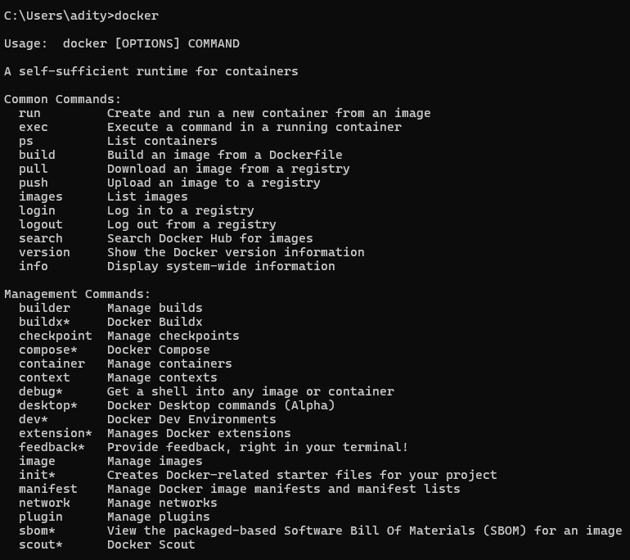

**Now, create a folder named ‘Terraform Scripts’ in which we save our different types of scripts which will be further used in this experiment.**

**Step 2:** Firstly create a new folder named ‘Docker’ in the ‘TerraformScripts’ folder. Then create a new docker.tf file using Atom editor and write the followingcontents into it to create a Ubuntu Linux container.

Script:

terraform

{ required_providers

{docker = {

source = "kreuzwerker/docker" version = "2.21.0"

}

}

}

provider "docker" {

host = "npipe:////.//pipe//docker_engine" }

# Pulls the image

resource "docker_image" "ubuntu" {name = "ubuntu:latest"

}

# Create a container

resource "docker_container" "foo" { image =

docker_image.ubuntu.image_idname = "foo"

}

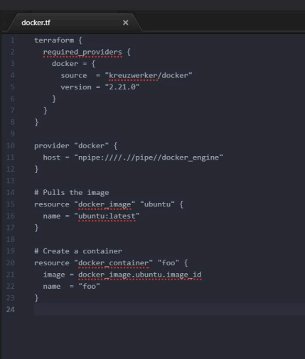

**Step 3:** Execute Terraform Init command to initialize the resources 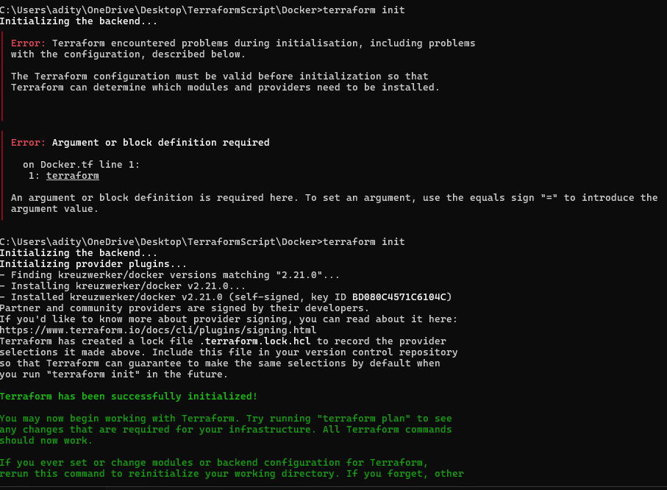**Step 4:** Execute Terraform plan to see the available resources

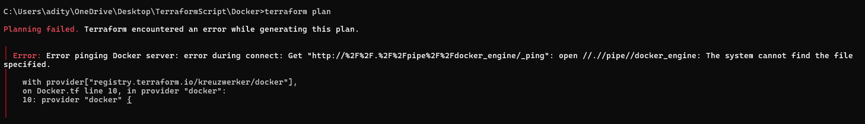

**Step 5:** Execute Terraform apply to apply the configuration, which will automatically create and run the Ubuntu Linux container based on our configuration. Using command : “**terraform apply”**

**v**Docker images, Before Executing Apply step:

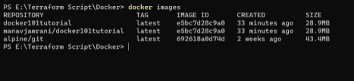

Docker images, After Executing Apply step:

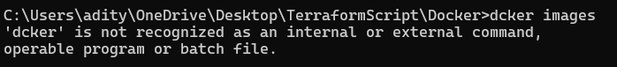

**Step 6:** Execute Terraform destroy to delete the configuration, which will automatically delete the Ubuntu Container.

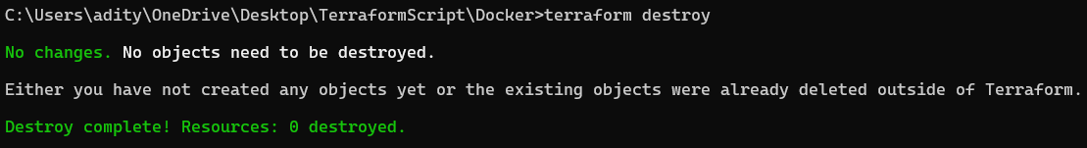

Docker images After Executing Destroy step

